1. Download Android studio from online and install.
2. Import the android project.

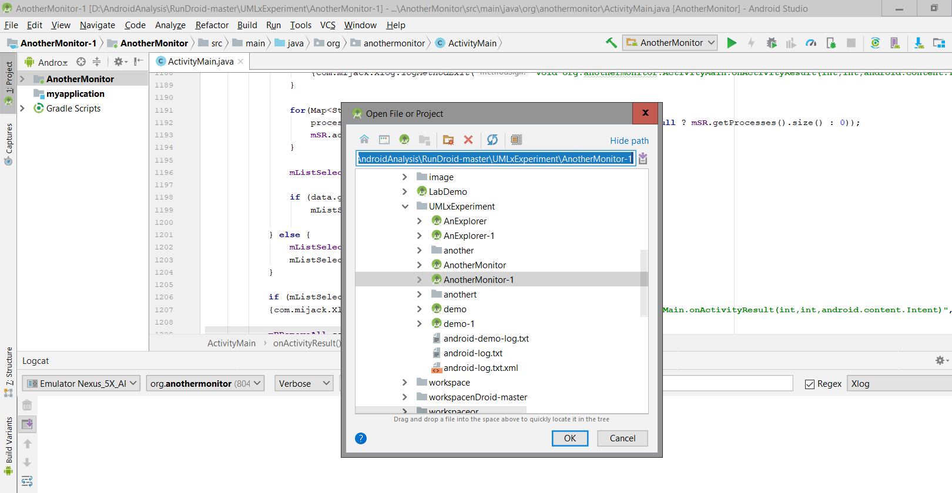

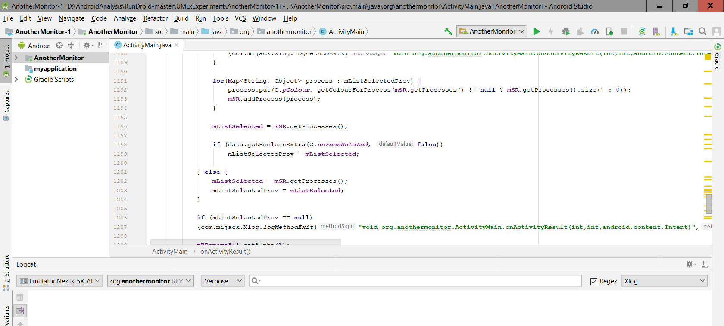

1. Solve any issues it may have from the build logs.

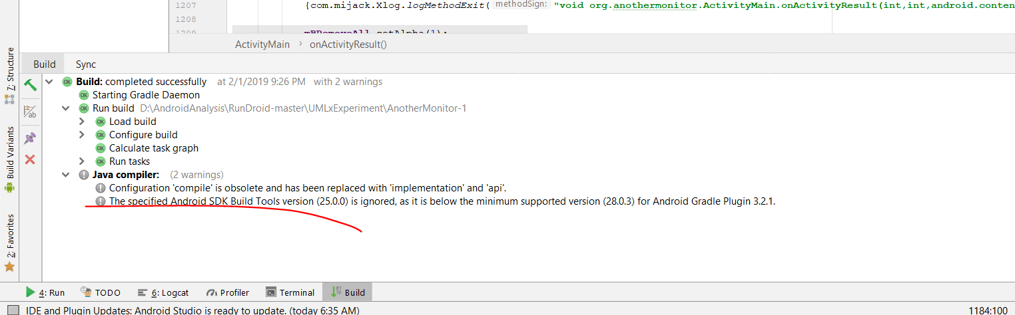

1. Compile and run the project

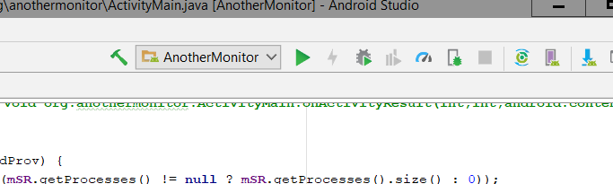

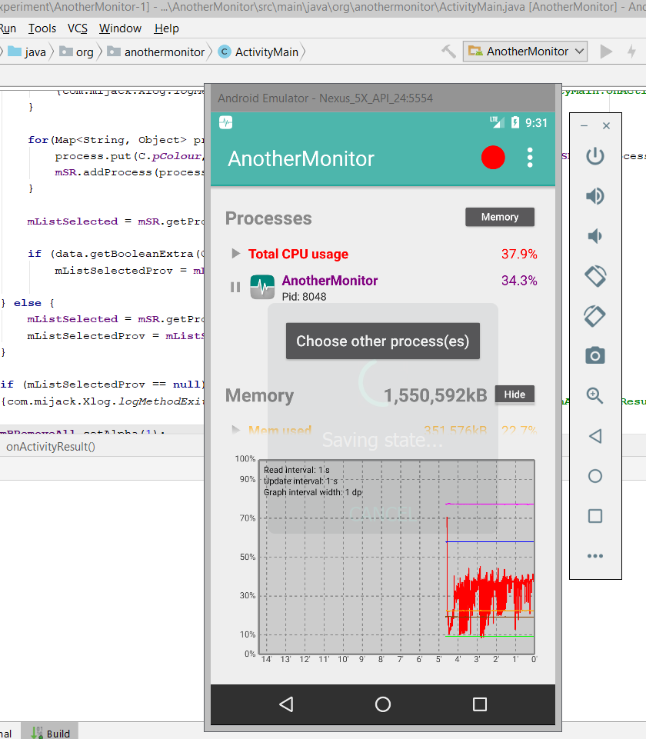

3. Export the apk following the path:

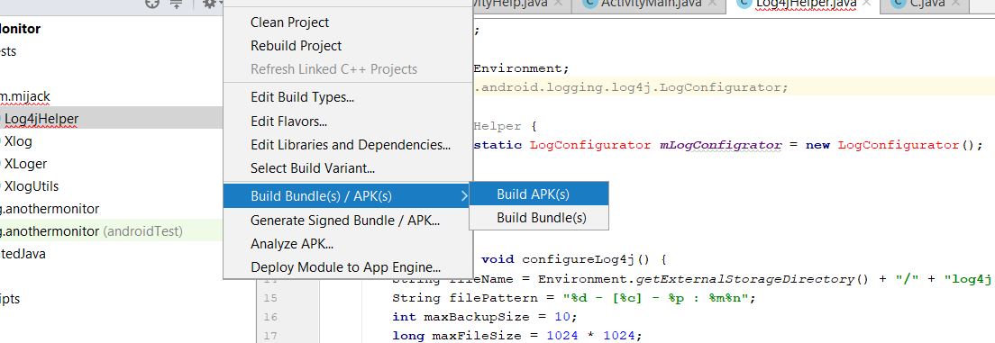

If key is required to sign the apk, please create one. It would be something as shown in the following screenshot:

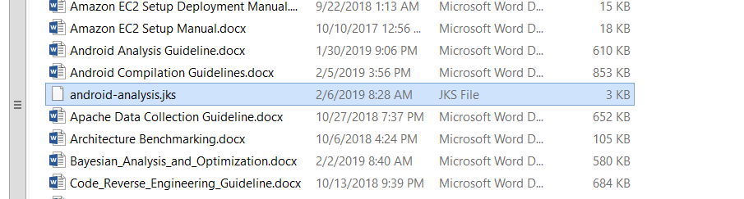

After we run compile the apps, save the compiled project source code and apks into this google folder:

https://drive.google.com/drive/u/2/folders/1Dl9wFfMH-nhlMe4aAmW6HMP3023rMhid

After compile the projects, we will need to insert the probes into the source code and establish the instrumented apps. Following the steps below to instrument the android apps.

1. Create copy of the compiled project, for example, as below:

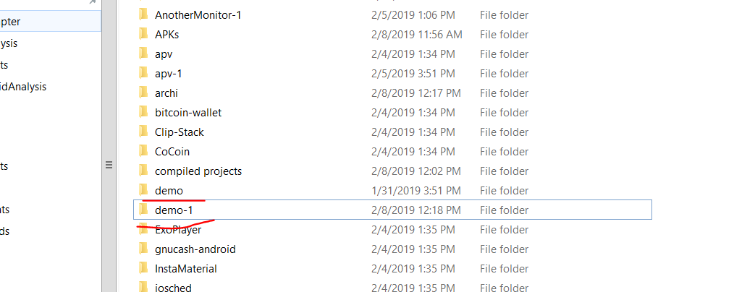

1. Instrument the source code using the command as below:

java -jar D:/ResearchSpace/ResearchProjects/UMLx/facility-tools/FaultProject/SourceInstrumt/target/SourceInstrumt-jar-with-dependencies.jar -java-input D:/AndroidAnalysis/RunDroid-master/UMLxExperiment/demo/src -java-output D:/AndroidAnalysis/RunDroid-master/UMLxExperiment/demo-1/src

\*before running the command, install srcml-win.exe (in the “./tools” folder) and add srcml into the “path” environment variables.

Usually run the instrument the java source code folder is fine, for example, the “src” folder.

* Replace the paths referenced in the command with your local path.

Check if the app is successfully instrumented:

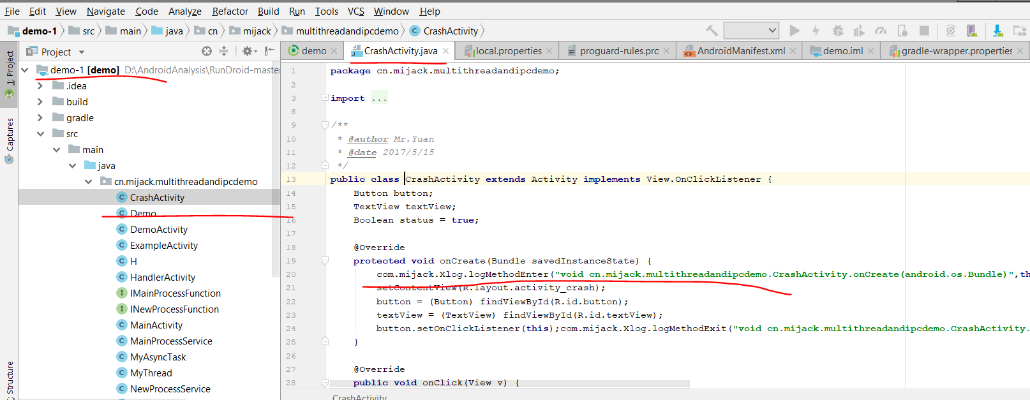

The apps that are successfully instrumented would have lines (as shown in the line of code underscored with the red color line) in every class file.

1. Copy the logging code package and libs to the corresponding folders of the project.

You can download the files from: <https://drive.google.com/drive/u/1/folders/1Dl9wFfMH-nhlMe4aAmW6HMP3023rMhid>

Copy “mijack” folder to the source code folder

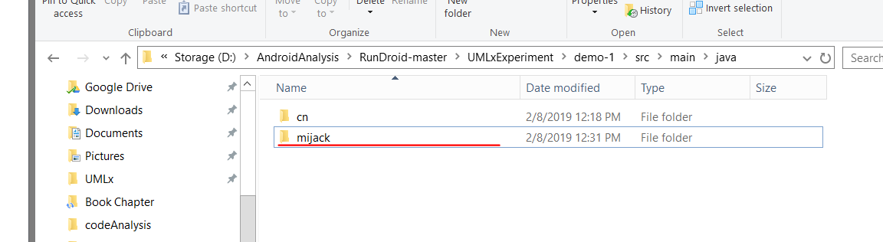

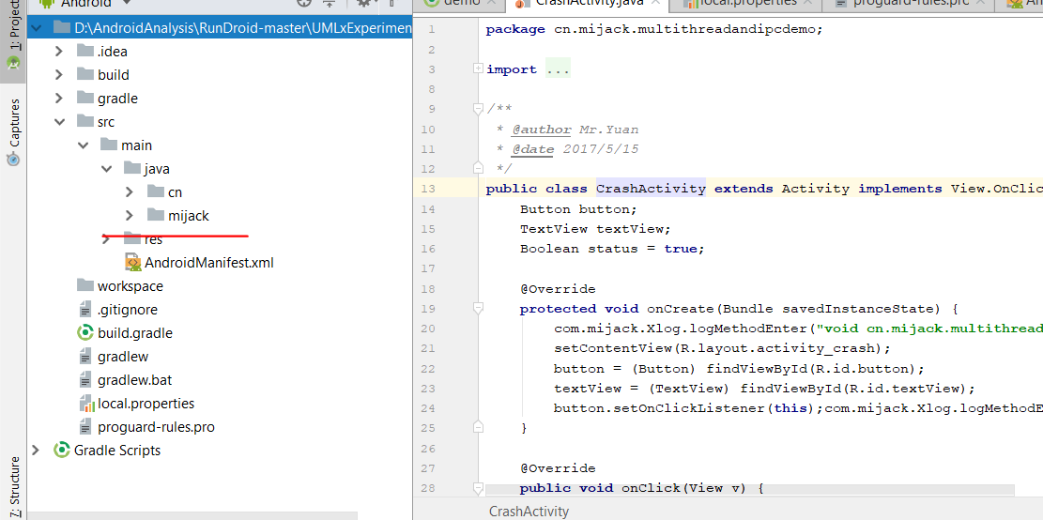

Update the line of source code (in the following screenshot) to the app’s name

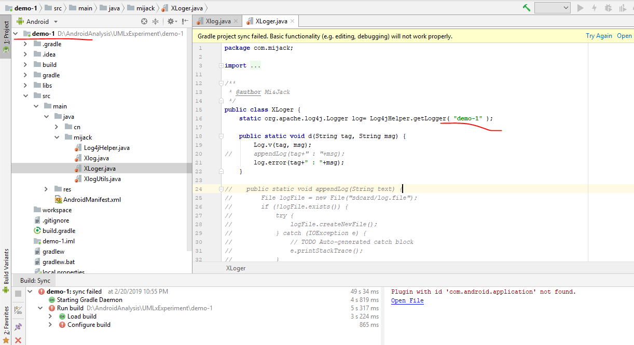

Copy “libs” folder to the project root folder

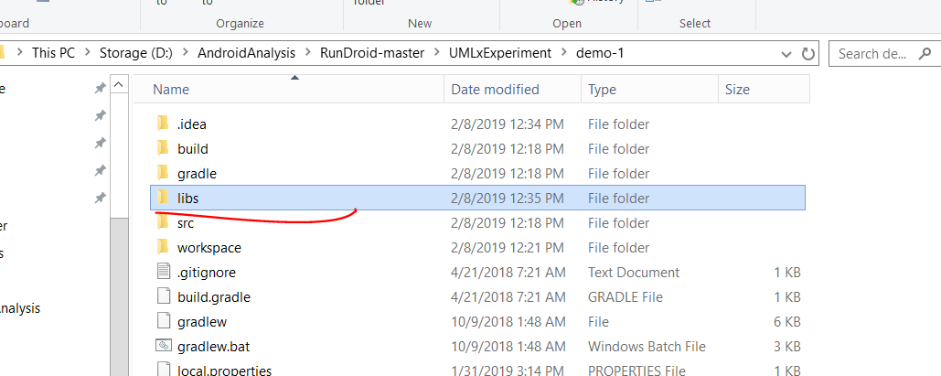

Make sure adding write permission to android (if it is not existing in manifest.xml before).

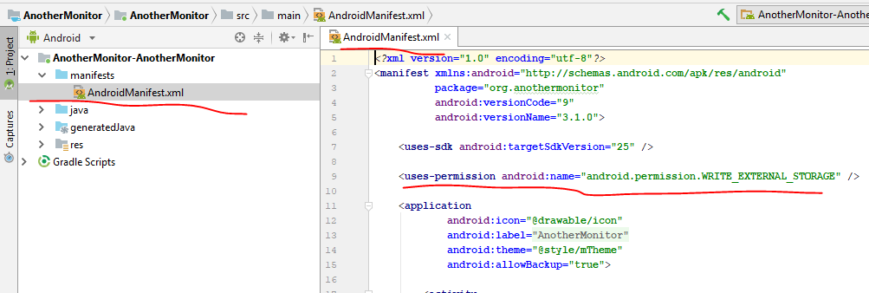

1. Import the instrumented app into android studio and try to re-compile them again.

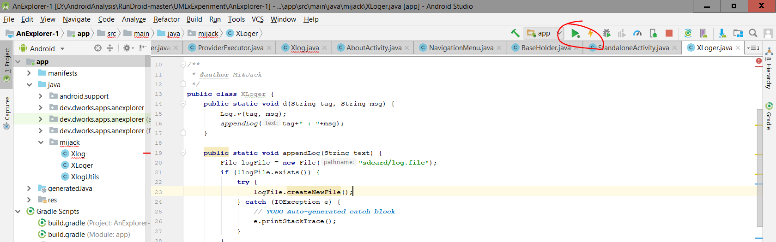

1. If there are any compilation issues (check as follows), try to solve them until they are successfully compiled. If there are issues related to the instrumented code (the code that is generated after the command), please let me know. I’ll have a look at it.

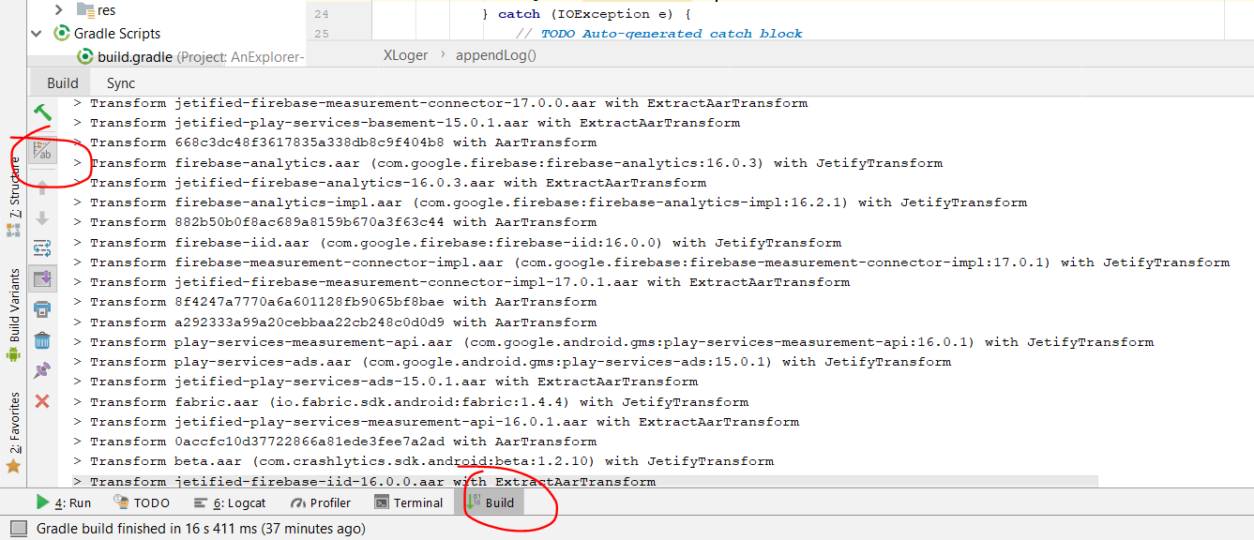

1. After instrumentation, please upload the instrumented source code and apks into:

<https://drive.google.com/drive/u/1/folders/11-XYoIbd6IU1zN26S--g1E12od1WIU6F>

Also do a record on the datasheet about what app has been added:

<https://docs.google.com/spreadsheets/d/14-YLB1cqJ7l67AZ-gfH-q4po2krPeQ5K68jnk5YevrM/edit#gid=0>

